**STRUCTUCTURE OF ATOM**

**(PART 2)**

**DEVELOPMENTS LEADING TO THE BOHR’S MODEL OF ATOM**

It is observed that all elements give characteristic line spectra (emission spectra) which could not explained on the basis of Rutherford’s nuclear model of atom. In order to understand line spectrum, in essential to understand the nature of light (or radiant energy) which in turn was explained first on the basis of "Electromagnetic wave theory" and then by "Plank's quantum theory”. Further with the advent of electromagnetic wave theory, it was found that Rutherford's model of atom suffered from a serious drawback. Hence a new model of atom Bohr's model of atom, was put forward. This model of atom was able to explain the drawback of Rutherford's model of atom and the main lines of hydrogen spectrum.

Now we shall discuss these developments one by one in brief.

**Wave Nature of Electromagnetic Radiation (Electromagnetic Wave Theory)**

This theory was put forward by James Clark Maxwell in 1864. The main points of this theory are summed up as follows:

1. The energy is emitted from any source (like the heated rod or the filament of a bulb through which electric current is passed) continuously in the form of radiations and is called the radiant energy.
2. The radiations consist of electric and magnetic fields oscillating perpendicular to each other and both perpendicular to the direction of propagation of the radiation (Fig 2.13).

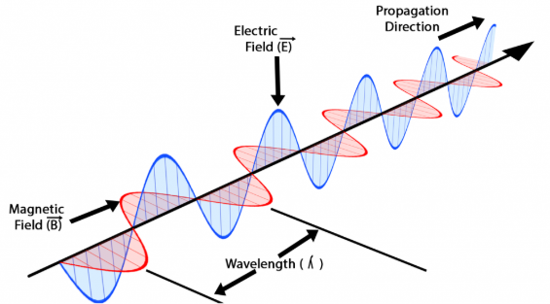

1. The radiations possess wave character and travel with the velocity of light (i.e., nearly 3 $× {10}^{8}$ m/sec). Because of the above characteristics, the radiations are called Electromagnetic radiations or Electromagnetic waves.
2. These waves do not require any material medium for propagation. For example, rays from the sun reach us through space which is a non – material medium.

Some important characteristics of a wave. The main Characteristics of a wave are its wavelength (ʎ), Frequency (v) and velocity (c).

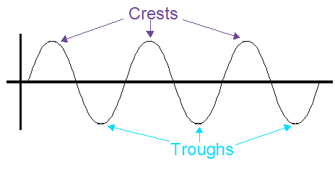

These are defined as follows:

**Wavelength**: It is defined as the distance between any two consecutive crests or troughs. It is represented by ʎ (lambda) and is expressed in $\begin{matrix}° \\ A\end{matrix}$ or m or cm or nm (nanometer) or pm (picometer).

1 $\begin{matrix}° \\ A\end{matrix}$ = = ${10}^{-8}$ cm = ${10}^{-10}$ m, 1 nm = ${10}^{-9}$ m, 1 pm = ${10}^{-12}$ m

**Frequency:** It is defined as the number of waves passing through a point in on second. It is represented by V (nu) and is expressed in Hertz (Hz) or cyleslsec or simply $\sec^{-1}$ or $s^{-1}$.

1 Hz = 1 1 cycle/sec

**Velocity:** It is defined as the linear distance travelled by the wave in one second. It is represented by c and is expressed in cm/sec or m/sec (m $s^{-1}$).

Besides the above three characteristics, two other characteristics of a wave are amplitude and wave number.

**Amplitude**: It is the height of the crest or the depth of the trough. It is represented by ‘a’ and is expressed in the units of length.

**Wave number:** It is defined as the number of waves present in 1 cm length. Evidently, it will be equal to the reciprocal of the wavelength. It is represented by $\begin{matrix}_ \\ V\end{matrix}$ (read as nu bar).

$$\begin{matrix}_ \\ V\end{matrix}=\frac{1}{ʎ}$$

if $ʎ$ is expressed in cm, $\begin{matrix}_ \\ V\end{matrix}$ will have the units ${cm}^{-1}$.

Period ($τ$) is the time taken for one wave to pass through a point. Hence, it is the reciprocal of

i.e.,

$$τ=\frac{1}{v}$$

if v in $s^{-1}$., $τ$ is in s.

Relationship between velocity, wavelength and frequency of a wave. As frequency is the number of waves passing through a point per second and ʎ is the length of each wave, hence their product will give the velocity of the wave. Thus, c = v $× ʎ$

**Electromagnetic spectrum:** The different types of electromagnetic radiations differ only in their wavelengths and hence frequencies. Their wavelengths increase in the following order:-

**Cosmic rays < $γ-$ rays < X – rays < UV rays < Visible < IR rays < Micro waves < Radio waves**

Spectrum is defined as the arrangement of various types of electromagnetic radiations in terms of increasing (or decreasing) wave lengths (or frequency). The complete range of electromagnetic waves is called electromagnetic spectrum.

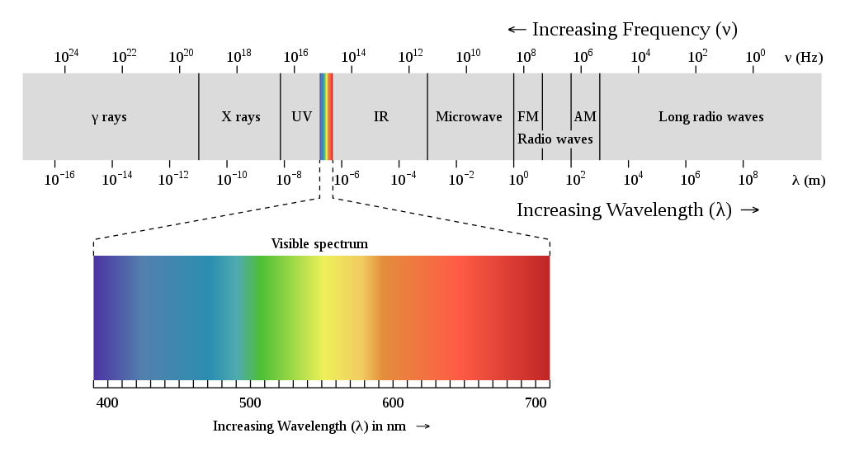

Since white is composed of lights of different wavelengths, a continuous spectra comprising of different wave lengths is obtained which is also known as Continuous spectrum. Light from incandescent bulb gives such type of spectra.

But when the spectrum is taken from the atoms of the gas present in the discharge tube it is found to be consisting of discrete lines of different colors. This is called line spectrum which is discontinuous one.

According to Rutherford’s atomic model, electrons revolving around the nucleus should lose energy continuously. Hence the spectra of atom should be a continuous one but the observed results are different.

In 1913, Danish scientist, Neils Bohr overcame the limitations of Rutherford model which is based on the quantum theory of radiation proposed by Max Planck.

**Planck’s quantum Theory of Radiation**

At the end of the 19th century, Physicists had an idea that matter and energy are different entities. Matter consists of particles which have mass and have specific positions in space.

German physicist. Max Planck, in 1901 carried out the first important experiment by studying the radiation emitted by solid bodies heated to incandescence.

He concluded from his experimental observation that energy can be absorbed or radiated by a body in the form of small packets of energy called quanta which are whole number multiples of the quantity hv where h = Planck’s constant = 6.625 $× {10}^{-34}$ joule sec.

v = frequency of the radiation

This theory proves the particle nature of energy.

The total amount of energy emitted or absorbed by a body will be some whole number multiple of quantum by an integer n.

E = nhv

where n is an integer for example, n = 1, 2, 3, ………etc

This implies that a body can emit absorb energy equal to hv, 2hv, 3hv, 4hv, …….etc……. but not in fractions i.e., 0.5 hv, 1.2 hv. Further we know that v = $\frac{c}{ʎ}$

Equation E = hv becomes E = $\frac{hc}{ʎ}$

This equation represent that a wave of higher frequency or lower wavelength will be more energetic and vice versa, for example, violet light of high frequency has more energy while the red light of low frequency is associated with less energy.

On the basis of this theory, Bohr proposed his atomic model.

**Bohr’s Model of an Atom**

Electrons revolve around the nucleus in specified circular paths called orbits or shells.

Each orbit or shell is associated with a definite amount of energy.

The energy associated with a certain energy level increases with the increase of its distance from the nucleus.

Hence if the energy associated with the K, L, M, N shells are $E_{1},E_{2},E_{3}$ respectively, then $E_{1}<E_{2}<E_{3}$ etc.

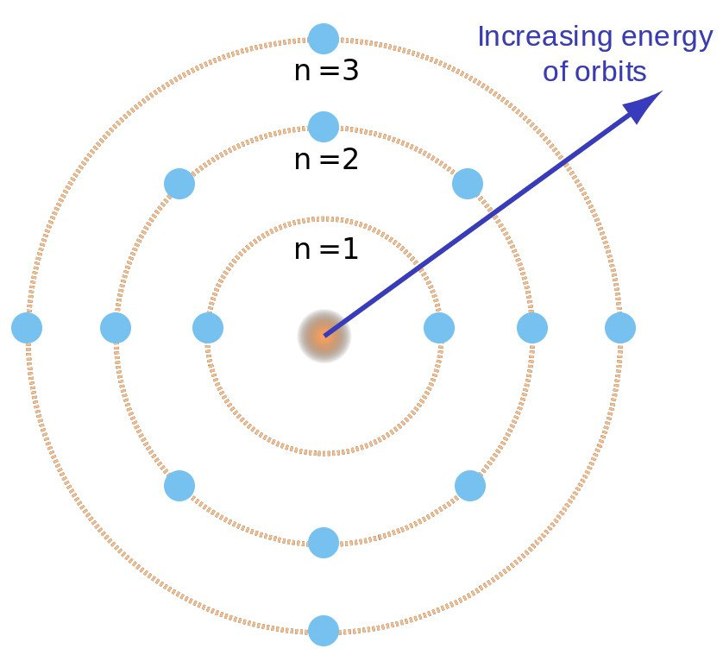

As long as the electron revolves in a particular orbit, the electron does not lose its energy. Therefore, these orbits are called stationary orbits and the electrons are said to be in stationary energy states.

An electron jumps from a lower energy level to a higher energy level, by absorbing energy, but when it jumps from a higher to lower energy level, the energy is emitted in the form of electromagnetic radiation. The energy emitted or absorbed ($∆$ E) is an integral multiple of ‘hv’.

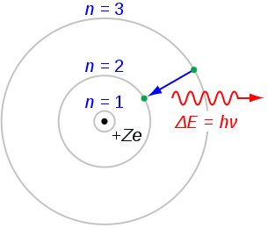

**Limitations of Bohr’s atomic model**

1. Bohr could not explain the spectral series for the multi electron atoms.

2. When the hydrogen spectrum was observed with the spectroscope of high resolving power, it was found that the individual lines in the spectrum consisted of several lines lying close to each other. This is called fine spectrum and he failed to explain structure of the spectrum.

**Quantum numbers**

We have studies that orbital is that area around the nucleus in which the probability of finding the electron is maximum. However, an atom contains a large number orbitals, which are distinguished from each other by their size, shape and orientation (direction) in space. The parameters by which orbitals are distinguished can be expressed by a set of numbers known as quantum numbers.

Thus, quantum numbers may be defined as set of numbers which display complete, information about size, shape and orientation of the orbital.

These are designated as principal quantum number (n), azimuthal quantum number (l) and magnetic quantum number (m). Thus, an orbital is designated by three quantum numbers. The fourth quantum number designated as spin quantum number (s), Represent the spin of electron i.e., rotation of electron about its own axis.

1. **Principal quantum number (n)**
2. It denotes the energy level to which the electron belongs.
3. It gives information about the maximum number of electrons that can be accommodated in any shell. Number of electrons in any shell is given by expression ${2n}^{2}$.
4. **Azimuthal quantum number or angular momentum quantum number (l)**
5. It tells about the number of subshells within a given principal energy shell to which the electrons belong. This quantum number is denoted by ‘l’. These subshells are designated by letters s, p, d and f for which l’ = 0, 1, 2, and 3 respectively.

|  |  |  |  |  |  |  |  |  |  |  |
| --- | --- | --- | --- | --- | --- | --- | --- | --- | --- | --- |
| N | 1 | 2 | | 3 | | | 4 | | | |
| L | 0 | 0 | 1 | 0 | 1 | 2 | 0 | 1 | 2 | 3 |
| Subshell | s | s | p | s | p | d | s | p | d | f |
| Designation of sub shell | 1s | 2s | 2p | 3s | 3p | 3d | 4s | 4p | 4d | 4f |

Thus, the total number of subshells for a given principal shell is equal to the value of n.

1. It tells about the relative energies of subshells belonging to same shell. The energies of different subshell present within the same principal shell are in the following order.
$$\begin{matrix}\underset{→}{s<p<d<f } \\ increasing energy \end{matrix}$$

2. **Magnetic quantum number (m or $m_{l}$)**
3. Magnetic quantum number gives the number of permitted orientations of subshells. For example, for a given value of ‘e’ the possible values of ‘m’ range from – l through 0 to + l. Each value of m corresponds to one atomic orbital. For example.

For s – subshell, l = 0 m = 0 i.e., s – subshell has one orbital

For p – subshell, l – 1 m = - 1, 0, + 1 i.e., s – subshell has three orbitals

For d – subshell, l = 2 m = -2, - 1, 0, +1, +2 i.e., d – subshell has five orbitals

For f – subshell, l = 3 m = - 3, - 2, - 1, 0, +1, + 2, + 3 i.e., f – subshell has seven orbitals

1. It explained successfully the splitting of spectral lines in the magnetic filed i.e., Zeeman effect.
2. **Spin quantum number (s) or ($m_{s}$)**

It has actually been observed that the electron in an atom is not only revolving around the nucleus but is also spinning about its own axis. Spin quantum number accounts for the spinning orientation of an electron The electron in an orbital can have only two types of spins i.e., in clockwise and anticlockwise direction. Therefore, the spin quantum number can have only two values i.e. + $\frac{1}{2} or- \frac{1}{2}$. The two spins of the electrons in an orbital are usually represented by arrows pointing in the opposite directions i.e. $↑and ↓$ respectively. The value of spin quantum number is independent of the values of other three quantum numbers.

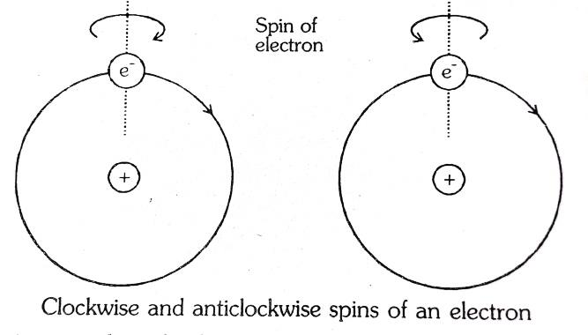

In order to fill the electrons in the orbitals, some rules are followed. These are,

**Aufbau principle**

In the ground state of the atoms, the orbitals are filled in order of their increasing energies. In other words, electrons first occupy the lowest energy orbital available to them and then enter into higher energy orbitals only when the lower energy orbitals are filled.

The order in which the energies of the orbitals increase and hence the order in which the orbitals are filled is as follows:

1s, 2s, 2p, 3s, 4s, 3d, 4p, 5s, 4d, 5p, 6p, 7s, sf, 6d, 7p, ………..

In neutral isolated atom, the lower the value of (n + 1) for an orbital, lower is its energy. However, if the two different types pf orbitals have the same value of (n + 1), the orbital lower value of n has lower energy.

This trend of increasing energies of various orbitals may be remembered in the form of following diagram.

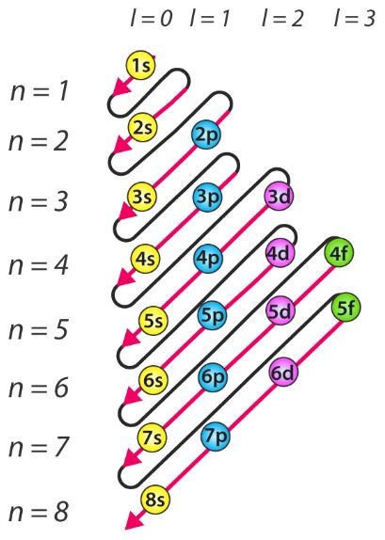

**Pauli’s exclusion Principle**

According to this principle “no two electrons in an atom can have the same set of all the four quantum numbers.”

In other words,

1. An orbital cannot have more than two electrons.
2. If an orbital has two electrons, they must have opposite spin i.e. they must be paried electrons.

**Hund’s rule of maximum multiplicity**

This rule deals with the filling of electrons into degenerate (equal energy) orbitals of the same sub – shell (p, d and f). According to this rule, Electron pairing in p, d and f orbitals cannot occur until each orbital of a given subshell contains one electron each or is singly occupied.

**Electronic configuration**

The assignment of all of the electrons in an atom into specific shells and subshells is known as the element’s electronic configuration.

A shell is designated by the principal quantum number (n). The subshell by the azimuthal quantum number existence of three electrons in the p subshell of the fourth shell (n = 4) is shown as follows.

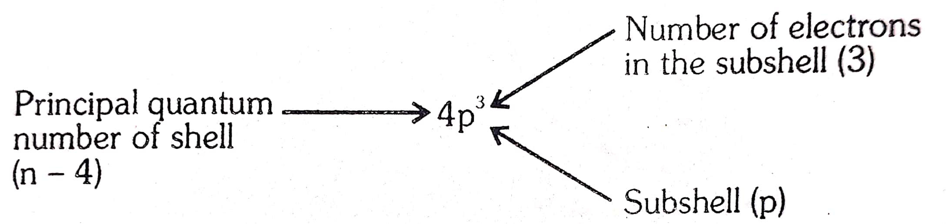

We begin with the ground state of the one electron in the simplest and first element, hydrogen. The electron is in the n = 1 shell, which has an s subshell. The electron configuration for H is ${1s}^{1}$.

The next element, helium, has two electrons. The 1s subshell has a capacity of two electrons, so He has the configuration ${1s}^{2}$.

Next comes Li with three electrons. The first two electrons fill the first shell, but the third is assigned to the second shell (n = 2). The second shell has two subshells, the s and the p, but s is lower in energy so it fills first. The next elements is Be. Its four electrons are also assigned to the 1s and 2s subshells. The electron configurations of Li and Be are,

Li: ${1s}^{2}{2s}^{1}$ Be : ${1s}^{2}{2s}^{2}$

The next element is B. Four of its five electrons have the same configuration as Be, but the fifth electron begins the filling of the next subshell, the 2 p. The next five elements, C to Ne complete the filling of the 2p subshell.

B: ${1s}^{2}{2s}^{2}{2p}^{1}$ N: ${1s}^{2}{2s}^{2}{2p}^{3}$ F: ${1s}^{2}{2s}^{2}{2p}^{5}$

C: ${1s}^{2}{2s}^{2}{2p}^{2}$ O: ${1s}^{2}{2s}^{2}{2p}^{4}$ Ne: ${1s}^{2}{2s}^{2}{2p}^{6}$

With the element neon, all of the orbitals in the second shell are full. We now continue with the element sodium, Which has 11 electrons. The first 10 electrons till the first and second shells, so the 11 th electron is assigned to the third shell. The third shell has three subshells. the 3s, 3p and 3d. The lowest in energy is the 3s subshell, so the 11th electron is in the 3s subshell. The atomic configurations of first 20 elements are shown below in the table

|  |  |  |
| --- | --- | --- |
| **ATOMIC NUMBER** | **ELEMENT** | **ELECTRONIC CONFIGURATION** |
| 1 | H | 1s1 |
| 2 | He | 1s2 |
| 3 | Li | 1s22s1 |
| 4 | Be | 1s22s2 |
| 5 | B | 1s22s22p1 |
| 6 | C | 1s22s22p2 |
| 7 | N | 1s22s22p3 |
| 8 | O | 1s22s22p4 |
| 9 | F | 1s22s22p5 |
| 10 | Ne | 1s22s22p6 |
| 11 | Na | 1s22s22p63s1 |
| 12 | Mg | 1s22s22p63s2 |
| 13 | Al | 1s22s22p63s23p1 |
| 14 | Si | 1s22s22p63s23p2 |
| 15 | P | 1s22s22p63s23p3 |
| 16 | S | 1s22s22p63s23p4 |
| 17 | Cl | 1s22s22p63s23p5 |
| 18 | Ar | 1s22s22p63s23p6 |
| 19 | K | 1s22s22p63s23p64s1 |
| 20 | Ca | 1s22s22p63s23p64s1 |

**Radioactivity**

We have already studied in ‘atomic strucutre’ that an atom is considered as being composed of three fundamental subatomic particles namely electrons, protons and neutrons. Neutrons and protons are the constituent particles of the nucleus (also known as nucleons), while electrons, are present in the extra – nuclear region. During a chemical reaction, the behavior of an atom is governed only by the number of electrons present in the extra nuclear part, while the nucleus of the participating atom has little influence on the reaction.

However, further studies about nucleus have revealed, that there are many unstable nuclei which keep on giving certain smaller particles and gamma radiations. As a result of this process, the unstable nuclei transform into new stable element. Such spontaneous transformation is called nuclear reaction or simply radioactive decay.

The phenomenon of radioactive decay was initially observed by Becquerel (1896) while performing experiments with potassium uranyl sulphate. Later investigations have shown that nuclei not only undergo radioactive decay but also undergo processes such as artificial transmutation, nuclear fusing, nuclear fission, etic. The study of all these phenomenon is done under branch of chemistry called nuclear chemistry.

The nuclear chemistry is thus defined as that branch of chemistry in which we study the composition of nuclei of atoms, nuclear forces, stability of the nucleus and the nuclear changes in the atom during reactions.

The study of nuclear properties of elements is classified into two categories.

1. Natural radioactivity
2. Artificial or induced radioactivity
3. **Natural Radioactivity**

A number of elements such as uranium, thorium, radium, polonium, etc, have unstable nuclei. These unstable nuclei disintegrate of their own resulting in the formation of a smaller atomic nuclei of another element. In this process, the protons and neutrons in the unstable nuclei regroup to give new nuclei, releasing the smaller particles and emitting radioactive radiations. All elements whose atomic nucleus emit highly penetrating radiations are called radioactive elements and the phenomenon is called radioactivity.

Thus, the radioactivity may be defined as the process of spontaneous disintegration or decay of unstable nuclei accompanied by emission of radiations.

The stable nuclei are found to have neutron/proton (n/p) ratio in the range 1 to 1.5. The nuclei whose n/p ratio lies outside this range (i.e., <1 or > 1.5) lose $α or β$– particles so that their n/p ratio shift into the stability belt.

Nature of radiations: The radioactive invisible radiations emitted out continuously by radium and other radioactive substances are not of one kind. Rutherford (1902) resolved these radiations into three types by placing uranium mineral in a lead box and passing emitted radiations between two oppositely charged plates as shown in figure.

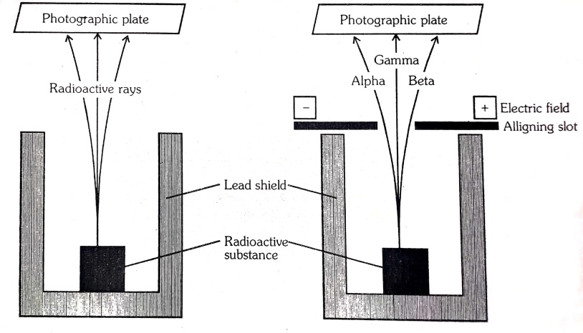

1. The radiations bending towards negative plate (cathode) show that these radiations are carrying positive charge and thus named as alpha rays or alpha particles ($α;2{He}^{4}$). These rays in fact, consist of merely helium nuclei.
2. The beam of rays which are deflected towards positive electrode (anode) show that these radiations are carrying negative charge and are known as beta particles ($β$). These rays are deflected to a much greater extent showing that $β-$ rays are lighter than those of $α-$ rays.
3. The third type of radiations, which are not deflected even in the strongest electric or magnetic field, are neutral and are termed as gamma rays ($γ$).

Radioactivity is a spontaneous emission of high energy radiation and particles from substance. This spontaneous emission happens because of two reasons:

1. disintegration of bigger element to smaller one (to reach stability)

For example, ${}_{6}^{14}C → {}_{7}^{14}N+ e^{-1},$

$${}_{92}^{238}{Ur} → {}_{90}^{234}{Th}+ {}_{2}^{4}{He}$$

This process is known as fission and it is used in Nuclear bomb.

1. Combining smaller atoms to form big one.

For example, Nuclear reaction in sun

$2_{1}^{3} → {}_{2}^{4}{He}+ 2{}_{0}^{1}n$

This process is known as fusion. The radioactivity was first experimentally experienced by Henry Becquerel.

**Properties of radioactivity**

The life of disintegration follow logarithmic curve as,

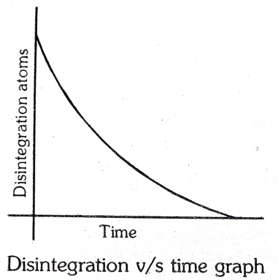

Its disintegration series is as follows, if ‘X’ initial amount and t is the half life.

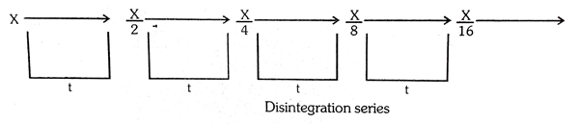

**Kinds of Radiations**

Further studies have shown that these three kinds of radiations are the characteristic properties of all radioactive unstable nuclei. The properties of each of these three kinds of radiations are briefly discussed below.

1. **Alpha ($α$) rays**
2. Nature: From the direction of deflection of $α-$ rays in the electric and magnetic field, it is evident that these rays carry positive charge. The alpha rays consist of alpha panicles carrying two units of positive charge and has mass nearly four times to that of hydrogen atom. In other words, alpha particles are merely helium nuclei consisting of 2 protons and 2 neutrons.
3. Velocity: $α$– particles have a velocity of over 16 $× {10}^{6}$ meter/sec or nearly $\frac{1}{10}$ th of that of light.
4. Ionizing power: $α-$ particles ionise the gas through which they pass. This is caused due to knocking
5. Penetrating power: The $α-$ particles have low penetrating power. These can penetrate through air upto a thickness about 7 cm before being absorbed. These can perpetrate upto 0.01 mm thick aluminium foil. This is because of their large size and thus these cannot pass through thick sheets of metal.
6. Luminescence: The $α-$ particles cause luminescence on striking a zinc sulphide screen. This is due to high kinetic energy – possessed by $α-$ particles.
7. Effect on photographic plate: $α-$ particles affect photographic plate.
8. **Beta ($β$) rays:**
9. Nature: The deflection of $β-$ rays in the electric and magnetic field have shown them to be identical with cathode rays. These carry negative charge and their e/m ratio is found to be identical to that of the electron. Thus these are designated as ${}_{-1}^{0}e or {}_{-1}^{0}β$.
10. velocity: Being much lighter than $α-$ particles these move much faster than the $α-$ particles. Their velocity is almost equal to that of the light.
11. Penetrating power: $α-$ particles are of small size and so move with high velocity. Thus these possess more penetrating power than $α-$ rays. These can penetrate through aluminium sheet of 2 mm thickness.
12. Ionizing power: Though $β-$ rays cause ionization of air but the effect is quite less. This is due to the fact that $β-$ particles is about 1/100th of that of $α-$ particles.
13. Luminescence: $β-$ particles have very little effect on the zinc sulphide plate. These do not show luminescence because they possess low kinetic energy.
14. Effect on photographic plate: $β-$ rays produce much greater effect than $α-$ rays on photographic plate.
15. **Gamma ($γ$) rays**
16. Nature: $γ-$ rays are the highly energetic electromagnetic radiations which are not deflected in the electric and magnetic fields. This shows that they do not carry any charge.

The production of gamma rays is subsequent with the production of $α-and β-rays$. After the emission of an $α-or β-particles,$ the nucleus is left behind in an excited state, i.e., in a state of high energy. The excess energy of the excited state is released in the form of gamma ($γ$) radiations. Their wavelength is of the order of ${10}^{8} to {10}^{-11}$ cm.

1. Velocity: They travel with the velocity comparable to that of light.
2. Penetrating power: These are highly penetrating rays amongst the three – kind of radiations. This is due to their high velocity and small wavelength. Their penetrating power is 100 times more than that of $β-$ rays. These can penetrate through an aluminium sheet of nearly 100 cm thickness.
3. Ionizing power: Their ionizing power is very poor because these do not possess any mass i.e., these are not material in nature.
4. Effect on zinc sulphide plate: Gamma rays have negligible effect on the zinc sulphide screen.
5. Effect on photographic plate: They produce either very little or no effect on the photographic plate.

The characteristic properties of $α, β and γ$ rays are compiled in the given table.

|  |  |  |  |  |
| --- | --- | --- | --- | --- |
| S.N | Property | $$α-rays$$ | $$β-rays$$ | $$γ-rays$$ |
|  | Symbol | $${α:}_{2}{He}^{4}$$ | $$β{; }_{-1} β^{0}{; }_{-1}e^{0}$$ | $$γ$$ |
|  | Charge | +2 | * 1 | 0 |
|  | Mass | 6.65 $× {10}^{-24}$ g | 9.11 $× {10}^{-28}$ g | Negligible |
|  | Nature of particles | High speed  (Helium nuclei) | High speed (electrons) | High energy (radiations) |
|  | Effect of electric and magnetic field | Deflected towards negative plate | Deflected towards negative positive Plate | Not deflected |
|  | Velocity | Nearly 1/10th to 1/20th to that of light | Nearly same as that of light (3.0 $×{10}^{10}$ cm/sec) | Same as that of light |
|  | Penetrating power | Small, being heavy particles | More than $α-$ particles. being lighter and of high velocity  Their penetrating power is ${10}^{2}$ times more than $α-$ rays | Very high, ${10}^{4}$ times more than $α-$ rays |
|  | Luminescence | Positive, i.e. it shows luminescence | Very little luminescence compared to $α-$ rays | No luminescence |
|  | Effect on photographic plate | These produce effect on photographic plate | Effect on photographic is less than $α-$ rays | Effect on photographic plate is least |

**EXERCISE 1**

1. An electron is in a 4f orbital. What possible values for the quantum numbers, n, l, m and s can it have?
2. Write down the quantum numbers n, l and m for the following orbitals:
3. 3d
4. 4d
5. 5d
6. 4p
7. 2p
8. 3s
9. Using s, p, d, f notations, describe the orbital with the following quantum numbers:
10. n = 2, l = 1
11. n = 4, l = 0
12. n = 5, l = 3
13. n = 3, l - 2
14. Which of the following sets of quantum numbers are not permitted?
15. n = 2, l = 2, m = - 1, s = +1/2
16. n = 2, l = 1, m = - 1, s = - 1/2
17. n = 2, l = 0, m = 0, s = 0
18. n = 2, l = 1, m = 2, s = + 1/2
19. Which of the following orbitals are not possible?

1p, 2s, 3f and 4d.

1. If n = 5, how many electrons can have $m_{l}$ = + 1?
2. If n is equal to 3, what are the values of quantum numbers l and m?
3. How many orbitals are present in the subshells with (a) n = 4, l = 2 (c) n = 5, l = 2?
4. What are the values of n, l and m for 2p – orbitals?
5. Write the correct orbital notations for each of the following sets of quantum numbers:
6. n = 2, l = 1,
7. n = 3, l = 0,
8. n = 5, l = 3
9. n = 4, l = 2?
10. Give the values of the quantum numbers for the electron with the highest energy is sodium atom.
11. Which of the following orbitals are not possible?

7s, 2d, 3f and 1p

1. Which of the following sets of quantum numbers are not possible?
2. n = 3, l = 2, m = 0, s = - 1/2
3. n = 3, l = 2, m = - 2, s = - 1/2
4. n = 3, l = 3, m = - 3, s = + 1/2
5. n = 3, l = 1, m = 0, s = + 1/2
6. Total number of orbitals associated with third shell will be…………..
7. 2
8. 4
9. 9
10. 3
11. Match the quantum numbers with the information provided by these.

Quantum number Information provided

1. Principal quantum number (a) Orientation of the orbital
2. Azimuthal quantum number (b) Energy and size of orbital
3. Magnetic quantum number (c) Spin of electron
4. Spin quantum number (d) Shape of the orbital

**EXERCISE 2**

1. The total number of atomic orbitals in fourth energy level of an atom is
2. 4
3. 8
4. 16
5. 32
6. Which set of quantum numbers is not possible?

n l m s

1. 3 2 0 +1/2
2. 2 2 1 + 1/2
3. 1 0 0 - 1/2
4. 3 2 - 2 + 1/2
5. 2 1 1 - 1/2
6. What is the maximum number of electrons that can be associated with the following set of quantum numbers?

n = 3, l = 1 and m = - 1

1. 10
2. 6
3. 4
4. 2
5. How many electrons can fit in the orbital for which n = 3 and l = 1?
6. 2
7. 6
8. 10
9. 14
10. What is the packet of energy called?
11. Electron
12. Photon
13. Positron
14. Proton
15. The frequency associated with photon of radiation having a wavelength of 6000 Å is
16. 5 $× {10}^{14}$ Hz
17. 5 $× {10}^{10}$ Hz
18. 2 $× {10}^{14}$ Hz
19. 5 $× {10}^{15}$ Hz
20. Bohr’s model can explain
21. The spectrum of hydrogen atom only
22. Spectrum of atom or ion containing one electron only
23. The spectrum of hydrogen molecule
24. The solar spectrum
25. When the speed of an electron increases (velocity of light is greater than velocity of electron), the specific charge
26. Decreases
27. Increases
28. Remains same
29. None of these
30. For which of the following species, Bohr’s theory does not apply?
31. H
$H^{+}$

${He}^{+}$

${Li}^{2+}$

32. The emission of light on heating a gas is due to
33. Excitation of electrons.
34. De – excitation of electrons.
35. Initial excitation and then de – excitation.
36. None of these
37. A ____is the smallest unit of waves in the form of which a hot body emits radiant energy and it can exist independently.
38. Electron
39. Proton
40. Quantum
41. Neutron
42. If S₁ is the specific charge (e/m) of cathode rays and S₂ be that of positive rays then which of the following is true?
43. S₁ = S₂
44. S₁ < S₂
45. S₁ > S₂
46. Any of these
47. Which one is the electronic configuration of ${Fe}^{+2}$?
${1s}^{2}, {2s}^{2}, {2p}^{6}, {3s}^{2} {3p}^{2}{3p}^{6} {3d}^{6}$

${1s}^{2}, {2s}^{2}, {2p}^{6}, {3s}^{2} {3p}^{2}{3p}^{6} {3d}^{4}{4s}^{2}$

${1s}^{2}, {2s}^{2}, {2p}^{6}, {3s}^{2} {3p}^{2}{3p}^{6} {3d}^{9}$

${1s}^{2}, {2s}^{2}, {2p}^{6}, {3s}^{2} {3p}^{2}{3p}^{6} {3d}^{10}, {4s}^{1}$

48. Radioactivity was discovered by
49. Neil Bohr
50. Henery Becquerel
51. Madam Curie
52. Albert Einstein
53. The atomic nucleus becomes unstable due to
54. High binding energy.
55. Low packing fraction.
56. High neutron – proton ratio.
57. Strong nuclear forces.
58. The unit of radioactivity is
59. Einstein
60. Becquerel
61. Curie
62. Rutherford
63. Consider the following two reactions, then atomic number and mass number of nucleus X and Y
64. $._{92}U^{235}$ + $._{0}N^{1}$ $→$ X + $._{35}{Br}^{85}$ + 3 $._{0}N^{1}$
65. $._{3}{Li}^{6}$ + $._{1}H^{2}$ $→$ Y + $._{2}{He}^{4}$
66. (i) 57, 148 (ii) 2, 4
67. (i) 57, 151 (ii) 4,4
68. (i) 60, 148 (ii) 4, 2
69. (i) 60, 15 (ii) 3, 4
70. When C – 14 is heated in a flame its half – life period
71. Decreases
72. Increases
73. Remains unchanged
74. becomes infinity
75. If the half life of a radioactive substance is higher, then its stability is
76. Low
77. High
78. Both
79. None of these
80. Which of the following consist of particles of matter?
81. Alpha rays
82. Beta rays
83. Cathode rays
84. All of these
85. The radioactive emission having the highest penetration power is
86. Visible light
87. X – rays
88. $γ-$ rays
89. $β-$ ray
90. Radioactive disintegration differs from a chemical change in being
91. An exothermic change.
92. A spontaneous process.
93. A nuclear process.
94. A unimolecular first order reaction.
95. When a heavier nucleus breaks down into two or more lighter nuclei of almost equal size, a large amount of energy is also liberated. This type of reaction is called as
96. Fission reaction.
97. Fusion reaction.
98. Spallation reaction.
99. Capture reaction.